cmccredits sheet — how to fill it in
This sheet handles two different things: forward credits (carrying an overpayment from one year into another) and adjustments (reducing a charge that won’t be paid in full). Both kinds live on the same sheet — the Source Year column tells the system which is which.

Quick reference
- Forward credit: Source Year = the year overpaid (e.g. 2025).
- Adjustment: Source Year = 0 (zero — that’s the marker that says “this is an adjustment, not a credit forward”).
- In both cases, columns B, C, D and E must all be filled in for the row to take effect. Date and Notes are optional.
- To stage a row in advance and have it ignored: leave column B (Property) blank. Fill it in when ready to go live.

1. Forward credit (overpayment carried to a future year)
Use this when a resident has overpaid in one year and the surplus needs to count toward a later year. The property’s overall outstanding doesn’t change — the credit just moves the surplus from one year row to another.

How to fill in the row
- Column A — Date: today’s date (optional but useful for audit).
- Column B — Property: pick the property from the dropdown.
- Column C — Source Year: the year that was overpaid (e.g. 2025).
- Column D — Amount: the surplus being carried forward (e.g. £480.00).
- Column E — Target Year: the year the credit is going into (e.g. 2026).
- Column F — Notes: optional, for your own records. Doesn’t appear on the page.

Example
13 The Courtyard overpaid by £480 in 2025. That £480 needs to count toward their 2026 charge.
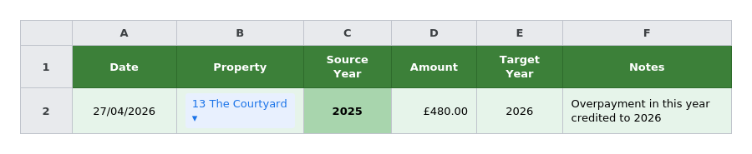

What this does on the page
- 2025 row shows a small italic note: “£480 credited forward to 2026”.
- 2026 row’s outstanding drops by £480, with the note: “includes £480 credit from 2025”.
- Property total Due and Outstanding figures are unchanged — money’s just been re-attributed.

2. Adjustment (reduce a charge that won’t be paid)
Use this when a charge needs to be reduced — agreed write-down, billing correction, dispute settlement, anything where the resident genuinely won’t be paying the full amount. The property’s overall outstanding drops by the adjustment amount.

How to fill in the row
- Column A — Date: today’s date (optional).
- Column B — Property: pick the property from the dropdown.
- Column C — Source Year: type 0 (zero). This is what marks the row as an adjustment.
- Column D — Amount: how much to take off the charge (e.g. £240.00 to reduce a £1,200 charge to £960).
- Column E — Target Year: the year the adjustment applies to (e.g. 2024).
- Column F — Notes: optional, for your own records. Doesn’t appear on the page.

Example
11 The Courtyard’s 2024 management charge of £1,200 needs to be reduced by £240, leaving £960 owed for that year.
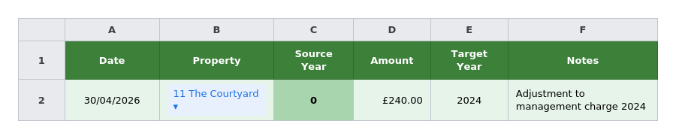

What this does on the page
- 2024 row’s outstanding drops by £240, with the note: “includes £240 adjustment”.
- Property total Due drops by £240.
- Property total Outstanding drops by £240.
- All other reports (Outstanding Balances, Grand Total bar, Previous Years dropdown, Property Statement) reflect the reduced amount.

Stacking adjustments
If a property needs adjustments for more than one year, add one row per year. Each row is independent. There’s no limit on how many can stack on one property.

Side-by-side
If you can only remember one thing:
- Forward credit — Source Year is a real year. The property’s total outstanding stays the same.
- Adjustment — Source Year is 0. The property’s total outstanding goes down.
Note: the page caches data. After adding a row to the sheet, give it a moment and refresh — sometimes a hard refresh is needed before the change shows up.

